Table X. Subscale scores by condition and results of Welch’s two-tailed independent-samples t-tests (n = 5 per group).
Subscale | Diegetic M (SD) | Non-diegetic M (SD) | t(df) | p | d
Competence satisfaction (1–7) | 6.07 (1.01) | 6.00 (1.35) | t(7.40) = 0.09 | .932 | 0.06
Competence frustration (1–7) | 2.40 (0.98) | 2.53 (1.22) | t(7.66) = −0.19 | .854 | −0.12
Tension/annoyance (0–4) | 1.33 (0.85) | 1.73 (1.30) | t(6.89) = −0.58 | .583 | −0.36
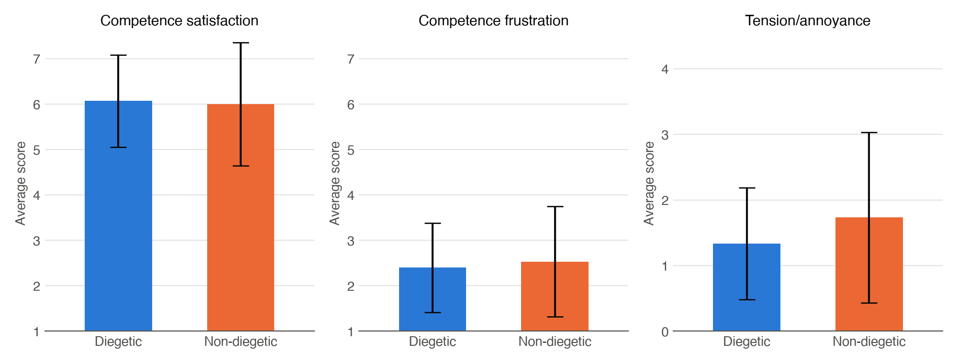
Figure X. Average scores for the diegetic (n = 5) and non-diegetic (n = 5) groups. Error bars show ±1 standard deviation. There were no significant differences between the groups on any measure (all p > .05).

